**Using Scratch to Teach Event-Driven Coding Skills**

**Commented Code**

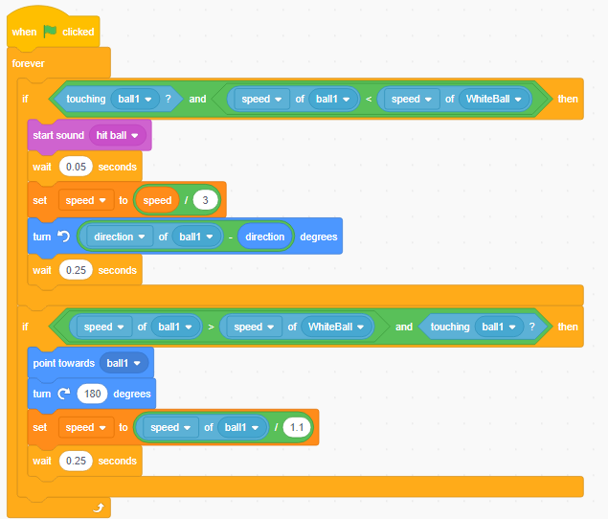This portion of the code effects how the white ball interacts with the other billiard ball

This will divide the speed of the white ball by 1.1

This causes the white ball to bounce off the other ball in the opposite direction

This sets the directional vector of the white ball towards the other pool ball

This checks if the white ball is colliding with the other ball again while it’s moving around the table

This will set the angle that the white ball will bounce off of the other pool ball

This will divide the speed of the white ball by 3

This will play a sound of two pool balls hitting

This checks if the white ball is hitting the other pool ball

While the game is running this code block will continue loop

This portion of the code effects how one of the other pool balls will interact with the white ball. The code is generally the same. Only variables and operators are changed. Use the previous page to help with the small changes.

The code below shows interactions between four different pool balls. Notice that the values are the same, but the variables are different.

The following code blocks set the locations of the barriers for the level 3 code. Each code sets them at a specific x and y-values

This puts the barrier in the top right corner

This puts the barrier in the bottom right corner

This puts the barrier in the bottom left corner

This puts the barrier in the top left corner

4

3

2

4

3

2

1

1

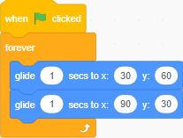

4

3

Glides the barrier from top right to bottom left

Glides the barrier from top right to bottom left

2

Glides the barrier from top left to bottom right

1

Glides the barrier from top left to bottom right

1

4

3

2